STUDENT JOURNAL OF PHYSICS © Indian Association of Physics Teachers
Presentations

Synthesis and Characterization of Innovative Multilayer, Multi Metal Oxide Thin Films by Modified Silar Deposition Method
P. Ghotane¹ and K. Deshpande²
¹ Third year, B. Sc, Department of Physics, Dr. Ghali College, Gadhinglaj –MS India 416502
² Third year, B. Sc, Department of Chemistry, Dr. Ghali College, Gadhinglaj –MS India 416502
Email: prashantghotane@gmail.com

Abstract: Multilayer, multi-metal oxide (CuNiO₄) thin films are deposited on glass substrate by modified SILAR deposition method. The chemicals copper chloride and Nickel acetate act as a cationic precursor solution and KOH as a anionic precursor solution. The SILAR is mainly based on the immersion of the substrate into separate cationic and anionic precursor solution and rinsing between each immersion with water to avoid precipitation. Effect of preparative parameters such as concentration, time, pH etc were studied and optimized to get uniform films. These thin films are found to be very useful in many applications like solar cells, sensors, temperature controller satellite etc. These films were characterized by X–ray diffraction and SEM techniques. The X–ray diffraction (XRD) data was used to determine of crystal structure. X-ray diffraction study reveals that the films are amorphous and optical study estimated the band gap value 2.56 eV.

- Introduction
Many chemical deposited metal oxide thin films including manganese oxide, cobalt oxide, tin oxide, and copper nickel oxide, etc. have been applied in supercapacitors [1]. The thin film deposition method involving the growth from solution is called chemical methods. Copper oxides exist in two stable forms, the cuprous oxides (Cu₂O) and the cupric oxides (CuO). These two oxides have very different colors, crystal structures, and physical properties. Simple chemistry tells that these differences are mainly due to the fact that Cu in Cu₂O is in the Cu+ state. Cu₂O is a red-colored cubic semiconductor. Nickel oxide has molecular formula NiO. Its molar mass is 74.6928 g/mol. Its density is 6.67g/mol. It is soluble in ammonium hydroxide.
225
Synthesis and Characterization of Innovative Multilayer, …. Modified Silar Deposition Method

Thin semiconductor films of CuNiO₂ are applicable in the various applications [2-5]. Our attempt is to prepare theCuNiO₂ thin films by the Successive Ionic Layer Adsorption and Reaction method (SILAR), which is very easy, inexpensive and relatively low temperature deposition method [6]. The thickness and other preparative parameters can be easily controlled by this method.
Thin film plays a vital role in the present day technology development. The different methods of thin film deposition offer a major key to the fabrication of micro and nanoscale devices [2]. The deposition of thin films by vacuum evaporation, spray pyrolysis, electrodeposition, anodization, electroless deposition, chemical bath depositions (CBD), successive ionic layer deposition (SILAR) etc. are well known methods [7]. Among these deposition methods, SILAR is simple, inexpensive and convenient for large area deposition.
2. EXPERIMENTAL
2.1 Substrate Cleaning
Before any substrate can be used, it must be adequately cleaned. The proper cleaning technique depends on the nature of the substrate, the nature of the contaminants and the degree of cleanness required. Cleaning involves the breaking of adsorption bonds between the substrate and the contaminants without damaging the substrate surface itself. The following procedure has been adopted for cleaning of the micro-slide (glass) substrates [8],
- The micro-slide was washed with double distilled water,
- Boiled in 0.5 M chromic acid for 1 h and kept in it for 24 hours,
- Washed with double distilled water and
Ultrasonically cleaned with double distilled water for 10 min and used prior to the deposition.

Student Journal of Physics, Vol. 5, No. 3, Oct., 2015

226
P. Ghotane and K. Deshpande

2.2 Preparation of Solution
The copper chloride, Nickel Acetate, and KOH is used for the solution preparation. The required amount of chemicals were weighed accurately and dissolved in double distilled water. All solutions of approximate concentration were prepared prior to the deposition.
2.3 Deposition of CuNiO₂ thin films
For the deposition of CuNiO₂ thin film 0.1 M of CuCl₂and 0.1 M of nickel acetate were used as cationic precursor solution and 0.1 M KOH was used as the anionic precursor solution. The well cleaned glass/stainless steel substrate was immersed in a cationic precursor solution for 10s for the adsorption of Copper Nickel species on the substrate surface. The substrate was rinsed in double distilled water for 5s to remove loosely bound species. Then the substrate was immersed in anionic precursor solution (KOH) for 10s to form layer of CuNiO₂material. Rinsing the substrate again in double distilled water in 10s to separate out excess and non-reacted species. Thus one SILAR cycle of CuNiO₂ deposition was completed. Then 80, 90, 100 and 110 cycles were repeated and different film thickness were obtained.
  - Reaction mechanism
The CuNiO₂ films were prepared by immersing substrate in separately cationic and anionic precursors with rinsing between every immersion. The growth kinetics of thin film deposition process is ion by ion growth mechanism, which involve the ion by ion deposition on substrate. The mechanism of CuNiO₂ is given as below.
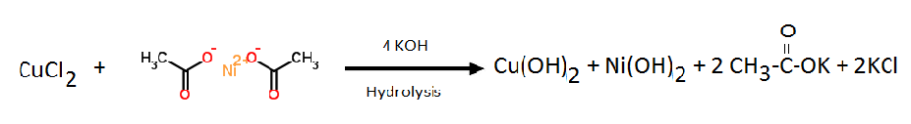

Student Journal of Physics, Vol. 5, No. 3, Oct-Dec, 2015

227
Synthesis and Characterization of Innovative Multilayer, …. Modified Silar Deposition Method

3. RESULTS AND DISCUSSION
3.1 X-ray diffraction (XRD) studies
Fig. 1 displays XRD pattern for CuNiO₂ thin film. CuNiO₂ spinel structure. It shows the amorphous nature. The small peak intensities in XRD pattern are attributed to the existence of fine grains.
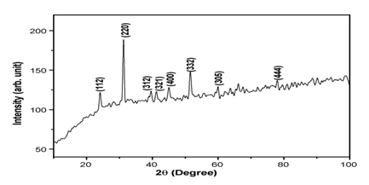
Figure 1: XRD pattern of CuNiO₂
3.2 Surface morphological studies
Fig.2 displays the scanning electron microscopy (SEM) images of randomly distributed corn nanoflakes ofCuNiO₂. The images are taken at four different magnifications of x 2,000, 5,000, 10,000 and 500 as shown in following figs..The average size of each rose varies between 1-50μm in diameter. There are randomly oriented nanoflakes for each rose; this may be because of faster nucleation rates during deposition.

Student Journal of Physics, Vol. 5, No. 3, Oct-Dec, 2015

228
P. Ghotane and K. Deshpande

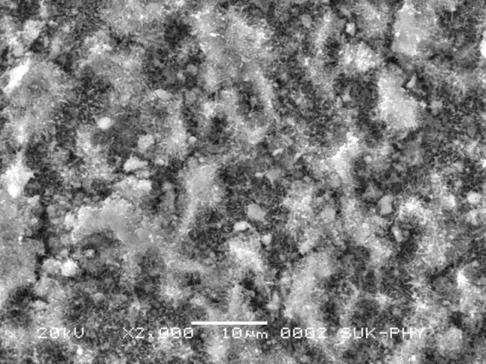
Figure 2: The SEM image of CuNiO₂ thin film.
3.3 Optical absorption studies
The optical absorption spectrum in the range of 350-900 nm for the CuNiO₂ film was carried out on to the glass substrate without scattering and reflection taking into account. Inset of Fig.3.4 shows the optical absorption of CuNiO₂ film. The absorption edge was found at nm due to optical band gap absorption. The optical band gap for CuNiO₂ film is calculated on the basis of optical absorption using the following equation,
$$\text{α=}\frac{A(\text{hν}−\text{Eg})^{n}}{\text{hν}}$$
Where α is absorption coefficient, Eg is band gap, A is constant and n is equal to 1/2 for direct transition. The plot of (αhυ) ² versus hυ of CuNiO₂ film is shown in fig. The band gap energy, Eg is obtained by extrapolating the linear portion of the plot (αhυ) ²versus hυ to the energy axis at α=0. From the graph for CuNiO₂ thin film, band gap value is 2.56 eV.
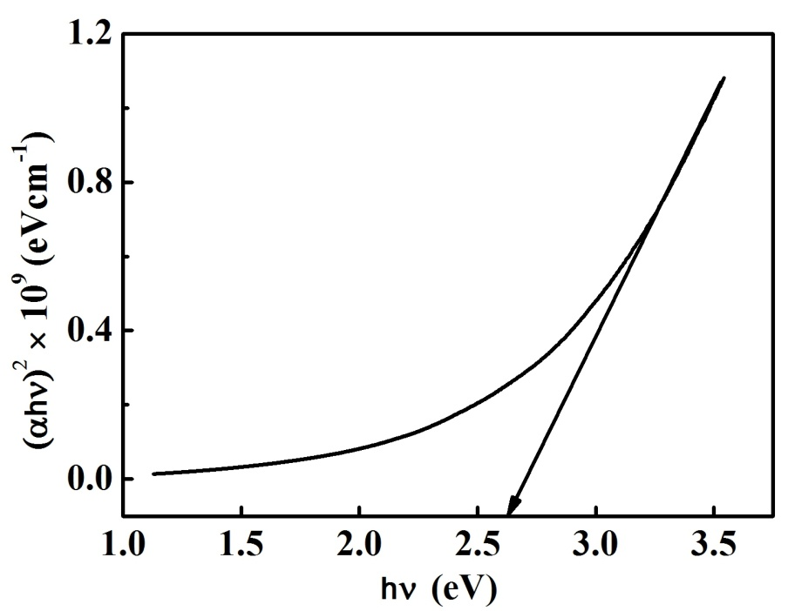
Figure 3: Shows Optical Characteristics of CuNiO₂ thin film
Student Journal of Physics, Vol. 5, No. 3, Oct-Dec, 2015

229
Synthesis and Characterization of Innovative Multilayer, …. Modified Silar Deposition Method

ACKNOWLEDGEMENT
The Authors are very much thankful to Dr. S.A. Masti, Head, Department of Physics, Prof. Ashwin Godghate and Prof. Kiran Patil of Department of Chemistry for their valuable help in completion of project.
REFERENCES
- K.L. Chopra, “Thin Film Phenomena”, Mc Graw Hill Book Co. New York (1969).
- Vinay Gupta, Norio Miura, Electrochem. Acta 52, 1721 (2006).
- Li Li Zhang and X.S. Zhao, Chem. Soc. Rev. 38, 2520 (2009).
- G. Wang, L. Zhang, and J. Zhangb, Chem. Soc. Rev. 41, 797 (2012).
- H. Pan, J. Li, and Y.P. Feng, Nanoscale Res. Lett. 5, 654 (2010).
- C.D. Lokhande, D.P. Dubal, and O.S. Joo, Curr. Appl. Phys. 11, 255 (2011).
- H.Q. Wang, Z.S. Li, Y.G. Huang, Q.Y. Li, and X.Y. Wang, J. Mater. Chem. 20, 3883 (2010).
- Y.B. Luo, J.S. Cheng, Q. Ma, Y.Q. Feng, and J.H. Li, Anal. Methods 3, 92 (2011).

Student Journal of Physics, Vol. 5, No. 3, Oct-Dec, 2015

230

